In React, there isn't a built-in command like Angular's CLI (**ng g c**) to generate a component. However, you can achieve this using tools or scripts.

**1. Using Custom Scripts**

You can create your own script to automate the generation of React components. For example:

**Example Script in Node.js**

1. Create a generateComponent.js script:
2. Run it with Node.js:

node generateComponent.js MyComponent

This will create a new directory src/components/MyComponent with a file MyComponent.jsx containing the component boilerplate.

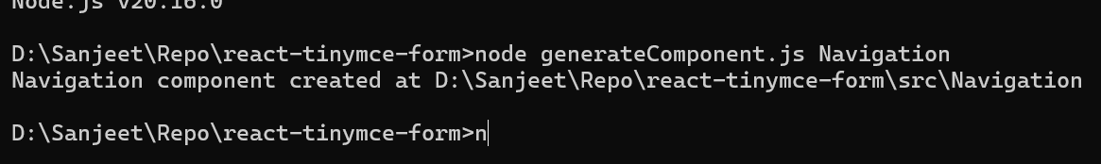

**3. Using a Boilerplate Tool**

You can use React CLI tools like create-react-app or vite for project setup, and manually structure your components. For generating components quickly:

* Install VS Code extensions like **ES7+ React/Redux Snippets**.
* Use terminal commands (mkdir, touch) to scaffold files and folders.

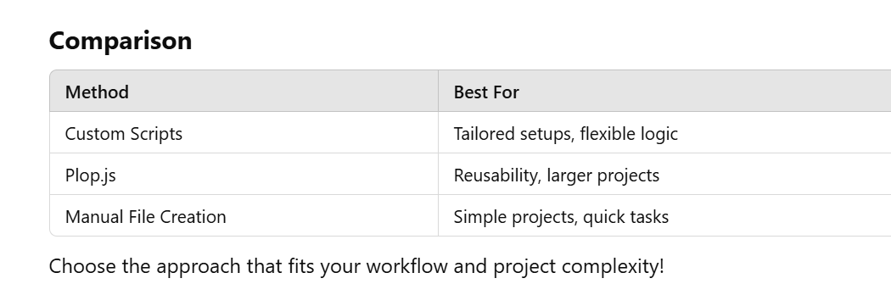

Both fs (File System) and path are built-in modules in Node.js, so you **don't need to install them** separately if you're running the script in a Node.js environment.

However, if you want to use fs and path in a frontend environment (like in a React app running in the browser), you'll need to reconsider because those are server-side modules and aren't available in the browser.

To summarize:

* **In Node.js environment (e.g., server-side or during build tasks)**: You **do not** need to install fs and path because they are built-in modules.
* **In a frontend environment (React app running in the browser)**: You cannot use fs or path directly because they're not available in the browser. You'd need to look into alternatives or move the logic to the server side.

If you're using generateComponent.js as part of a build or setup process (like generating React components automatically), it’s most likely being run in a Node.js environment, so you don’t need to install fs and path separately. You can directly use them.